**Lwandle Msiya**

**ST10406108**

**PROG6212 Part 2**

**Documentation:** Design Choices, Database Structure, and GUI Layout

**1. Introduction**

The CMCS (Claims Management and Control System) is created to make handling employee claims easier and faster. It helps in submitting, reviewing, and approving claims in a more efficient, clear, and user-friendly way.

**2. Design Choices**

**2.1 User Interface (UI) and User Experience (UX)**

**Simplicity and Clarity:** The interface is designed to be simple so that everyone can use it easily. Forms are straightforward with clear labels to avoid confusion.

**Color Scheme:** We use a dark green background for a professional and calm look. White text on this background ensures that everything is easy to read. Form fields have a lighter background to make data entry clear.

**Responsiveness:** The design adjusts well to different screen sizes, so users can access the system from desktops, tablets, and smartphones without issues.

Feedback Mechanisms: After submitting a form, users get immediate feedback, like a success message, to confirm their action. This helps reduce anxiety and improves the experience.

**2.2 Database Structure**

The database is organized in a way that makes it easy to manage and find data. Here’s a summary of the main tables:

**Users Table:**

**Fields**: user_id, name, surname, employee_no, contact_details, role.

**Purpose:** Stores details about users, distinguishing between different roles like claimants and administrators.

**Claims Table:**

**Fields:** claim_id, user_id, hours_worked, programme, module_code, groups, hourly_rate, total_amount, status.

**Purpose:** Keeps records of each claim submitted by users and links them to specific users.

**Approval Table:**

**Fields:** approval_id, claim_id, approved_by, approval_status, approval_date, comments.

**Purpose:** Tracks the approval process, showing which claims are approved or rejected and by whom.

**Audit Log Table:**

**Fields:** log_id, action, user_id, timestamp, details.

**Purpose:** Records all actions within the system for transparency and accountability.

**2.3 Backend Logic**

**Validation:** The system checks inputs both on the client side (using JavaScript) and server side to avoid errors or malicious data.

**Automated Calculations:** The total claim amount is calculated automatically based on the hourly rate and hours worked, which reduces mistakes and speeds up the process.

**Role-Based Access Control:** Users have different permissions based on their roles. For example, administrators can approve or reject claims, while regular users can only submit and edit their own claims.

**3. GUI Layout**

**3.1 Claims Submission Form**

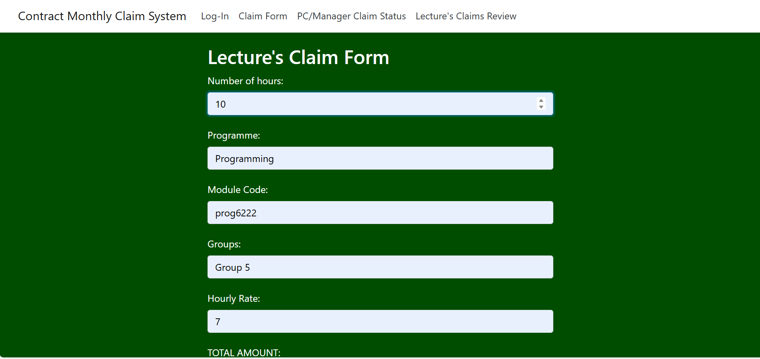

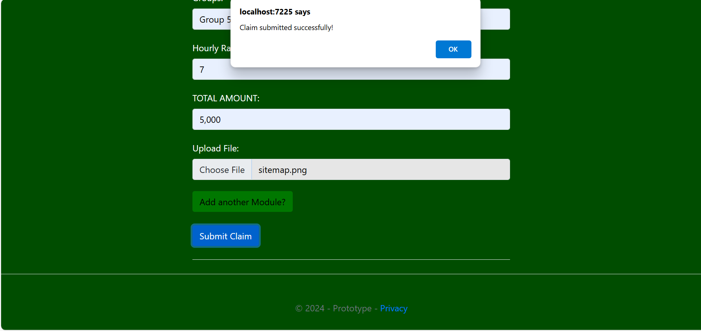

**Fields:** Includes fields for hours worked, program, module code, groups, hourly rate, and total amount. All necessary for a claim.

**Buttons:** Contains a “Submit Claim” button to start the submission process.

**Feedback:** Shows a success message after the claim is submitted.

**3.2 Claims Table(PC & Manager view of Lecture’s Claim)**

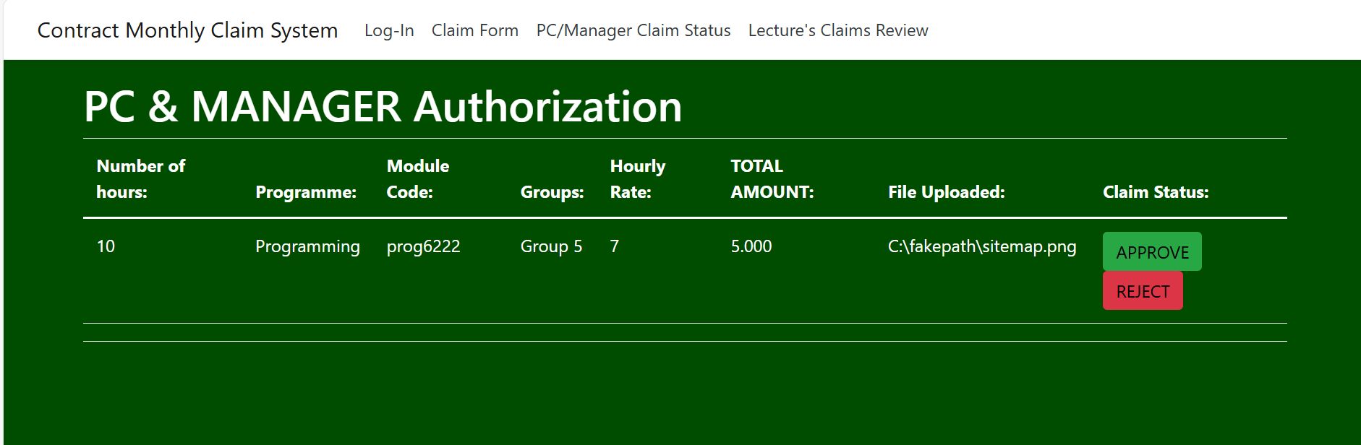

**Layout:** Displays all claims submitted by the user with details like hours worked, program, module code, groups, hourly rate, and total amount.

**Actions:** Each row has options to edit or delete the claim. Administrators also have buttons to approve or reject claims.

**3.3 Log-in Form**

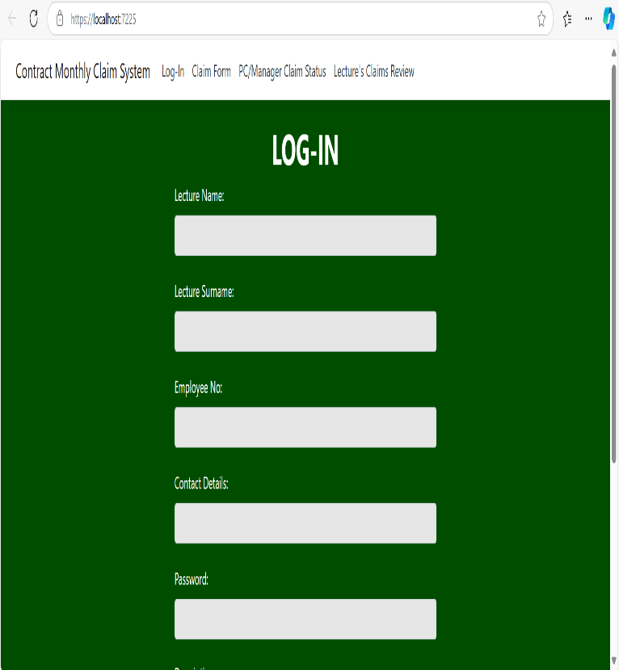

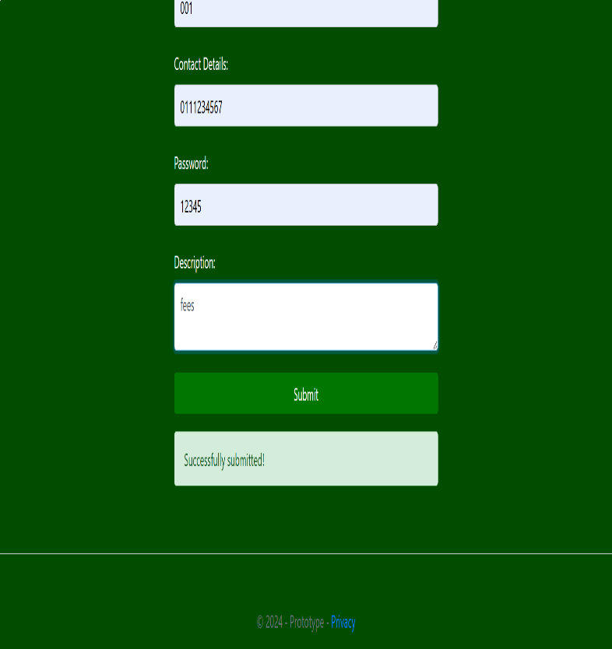

**Layout:** The first page you will come across as soon as application is ran. A basic log-in page.

**Actions:** Collects Lecture information for the Lecture

**3.4 ClaimReview View (Lecture’s view of claim)**

**Pending Claim:**

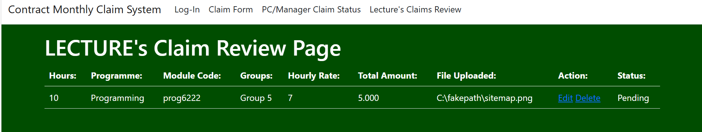

**Edited claim:**

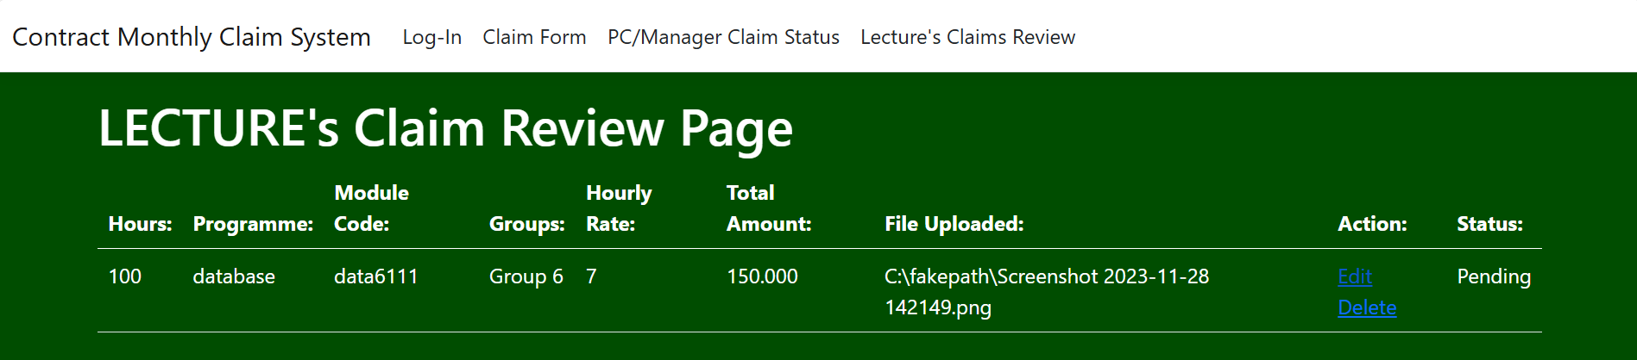

**Approved and/or Rejected Claim(PC/Manager Buttons on their view):**

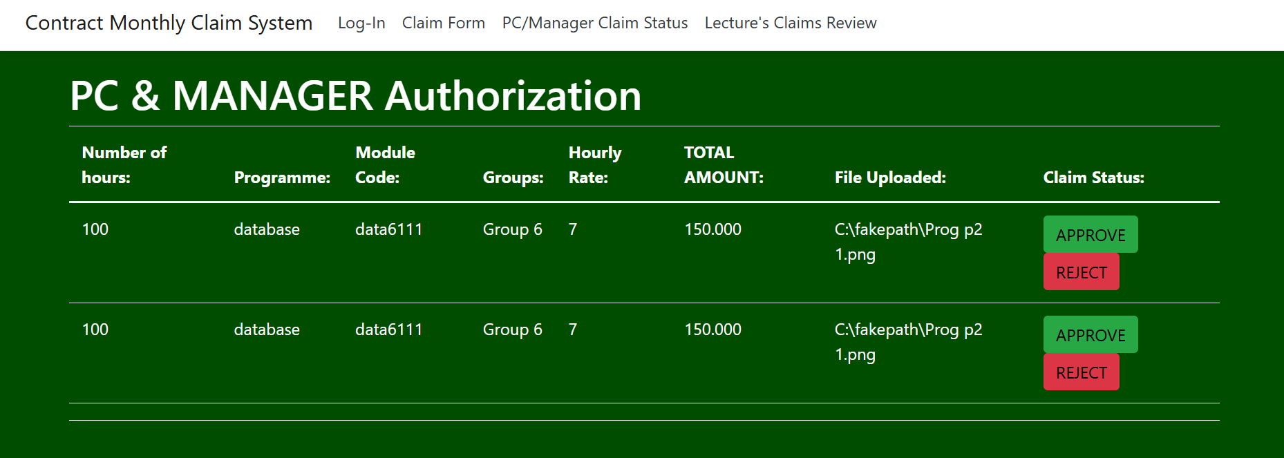

**When approved, sends back a success message:**

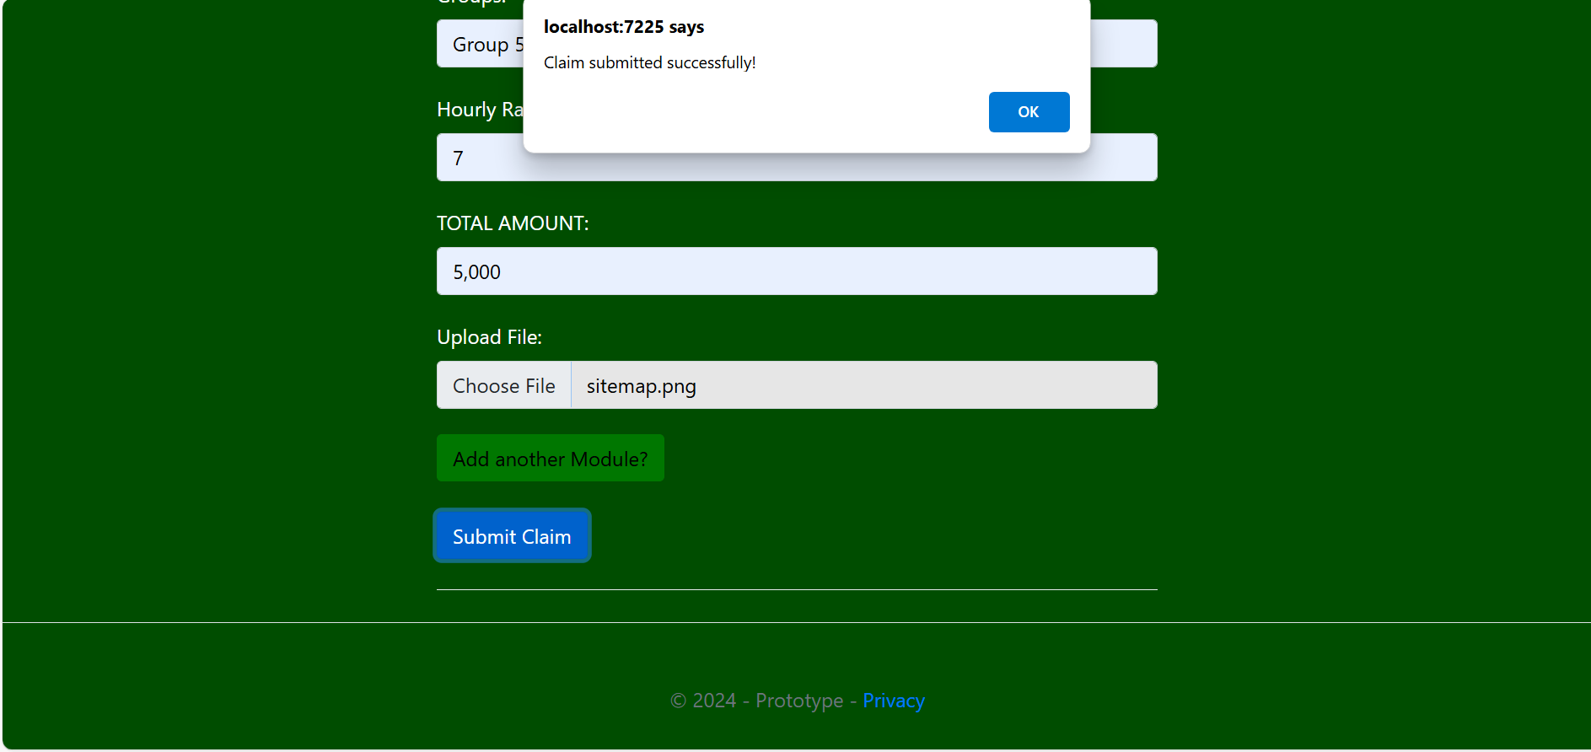

**When rejected, asked for reason:**

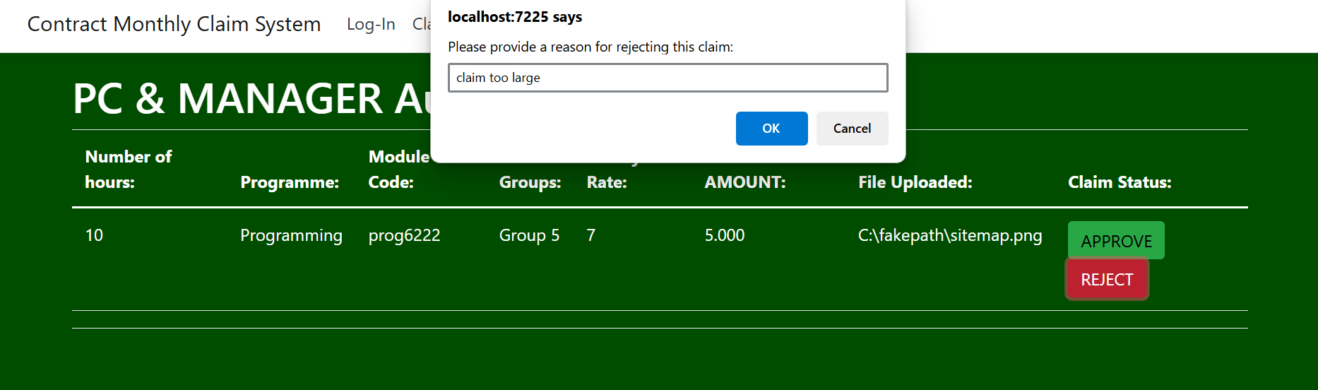

**Approved/Rejected message (Lecture’s view):**

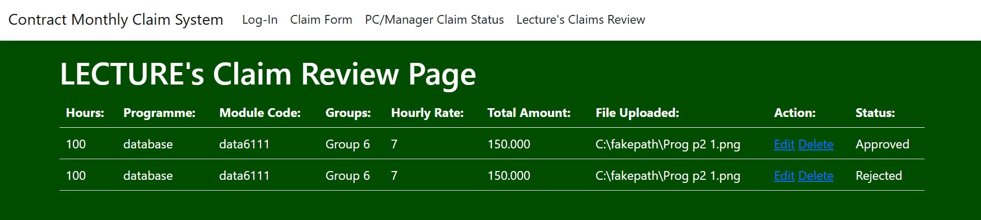

**Deleted Claim (lecture side):**

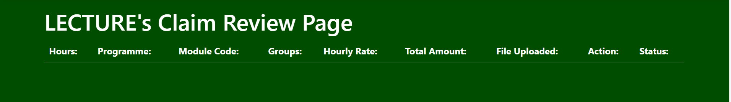

**Deleted Claim (PC/Manager side):**

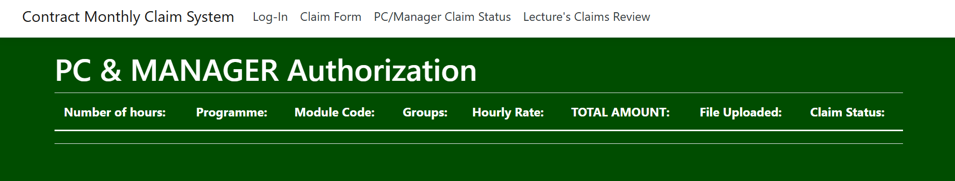

**3.5 Footer**

**Positioning:** The footer is centered at the bottom of the page and provides basic information like the copyright notice.

**4. Assumptions and Constraints**

**4.1 Assumptions**

Users can handle basic digital tasks and navigate standard web applications.

Claims are based on a consistent hourly rate across the organization.

**4.2 Constraints**

The system is suited for small to medium-sized organizations; scaling up may need additional changes.

Requires a stable internet connection for submitting and retrieving claims.

**5. Conclusion**

The CMCS application was built to be efficient, transparent, and easy to use. The choices made in its design, database structure, and backend logic are aimed at meeting these goals while being flexible for future improvements. This system simplifies managing claims, reducing administrative work, and ensuring employees get paid on time.

**REPORT**

**The CMCS REPORT**

**INTRODUCTION**

The CMCS (Claims Management and Control System) application is a helpful tool designed to make it easier for employees to submit, review, and approve various claims within an organization. This system is especially useful in places like schools or companies, where employees like lecturers or office staff need to request payment for extra work they have done outside their regular duties. This report gives an overview of what the claims form is for and how the CMCS application works.

**PURPOSE OF THE CLAIMS FORM**

The claims form in the CMCS application is a document where employees can request payment for extra work they have done. This form collects important details needed to process and check claims, making sure everything is clear and fair. The information typically included in this form covers:

**-Number of Hours Worked:** Employees need to write down the exact number of extra hours they worked. This is important for calculating how much money they should be paid, as most claims are based on the number of hours worked.

**- Programme and Module Code:** Employees need to specify the program and module code related to the work they did. This is particularly important in schools where claims might be linked to specific courses or projects.

**- Groups:** The form also asks for information about the specific groups or classes for which the work was done, ensuring the claim is correctly connected to the employee’s duties.

**- Hourly Rate:** This field is used to record the rate at which the employee is paid for the extra hours worked. This rate is used to calculate the total amount to be claimed.

**- Total Amount:** The last part of the form shows the total amount of money being claimed by the employee, based on the hours worked and the hourly rate.

**-File Uploaded was added:** To capture any files selected when the lecture is submitting the claim.

**APPLICATION OF THE CMCS SYSTEM**

The CMCS application is designed to make managing these claims easier. The system offers several key features:

**- Form Submission:** Employees can quickly submit their claims online using an easy-to-use interface. This gets rid of the need for paper forms and reduces the chance of mistakes.

**- Review and Approval Workflow:** After a claim is submitted, it can be reviewed by the relevant people in the organization. The system allows claims to be approved or rejected, with the option to give feedback or ask for more information.

**- Tracking and Accountability:** The CMCS application keeps a clear record of all claims submitted, approved, or rejected. This ensures there is a clear trail for all claims, which is important for keeping things fair and transparent in the organization.

By sending “Approved”, ”Rejected” or “Pending” based on what option the PC/Manager chooses.

**- Efficiency and Time-Saving:** By automating the claim submission and approval process, the CMCS reduces the amount of work for both employees and managers. This allows claims to be processed faster, ensuring that employees are paid on time.

**CONCLUSION**

The CMCS application and its claims form are essential tools for managing employee claims within an organization. By providing a clear, efficient, and fair process for submitting and reviewing claims, the CMCS improves how the organization runs and ensures that employees are properly paid for their extra work. This system is particularly useful in environments where keeping track of work hours and timely payment are important for keeping employees happy and maintaining fairness in the organization.

**WORDS:**523

**GITHUB LINK :** [**https://github.com/Lwagit/Prototype**](https://github.com/Lwagit/Prototype)